Project: Object/Image Recognition using Convolutional Neural Network (CNN).

Ref
1) https://www.anaconda.com/
2) http://yann.lecun.com/exdb/mnist/
3) https://www.python.org/
4) https://www.tensorflow.org/tutorials/estimators/cnn
5) https://keras.io/layers/convolutional/

Summary:
A Simple Neural Network (NN) and Convolutional Neural Network (CNN) will be used to accomplish Image Recognition. NN is used as benchmark comparison for the CNN (educational purposes); the analysis will be accomplished using a simple NN and compared to the CNN on the very same dataset

Convolutional Neural Networks
Ref(4): Convolutional Neural Networks (CNNs) are the current state-of-the-art model architecture for image classification tasks. CNNs apply a series of filters to the raw pixel data of an image to extract and learn higher-level features, which the model can then use for classification. CNNs typically contain three components:

- Convolutional layers, which apply a specified number of convolution filters to the image. For each subregion, the layer performs a set of mathematical operations to produce a single value in the output feature map. Convolutional layers then typically apply a ReLU activation function to the output to introduce nonlinearities into the model.

- Pooling layers, which downsample [dimensionally reduce] the image data extracted by the convolutional layers to reduce the dimensionality of the feature map in order to decrease processing time. A commonly used pooling algorithm is max pooling, which extracts subregions of the feature map (e.g., 2x2-pixel tiles), keeps their maximum value, and discards all other values.

- Dense (fully connected) layers, which perform classification on the features extracted by the convolutional layers and downsampled by the pooling layers. In a dense layer, every node in the layer is connected to every node in the preceding layer.

The final dense layer (typically called "fully connected") in a CNN contains a single node for each target class in the model (e.g. all the possible classes the model may predict), with a softmax activation function to generate a value between 0–1 for each node (the sum of all these softmax values is equal to 1). Interpret the softmax values for a given image as 'relative measurements' of how likely it is that the image falls into each target class.

Reviewing Neural Network Architecture
The following identifies the components typical to Neural Networks, see fig(3)
Note: w is weight, a = activation value, b = bias, z = activation function from the neuron the arrow is coming from.

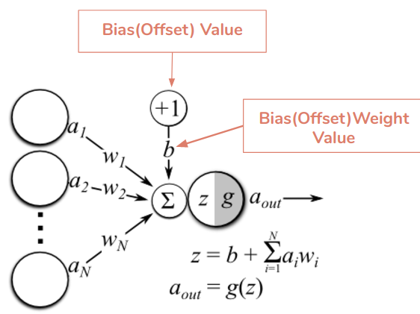
fig(3)

Simple Neural Network showing MNIST Digit Dataset

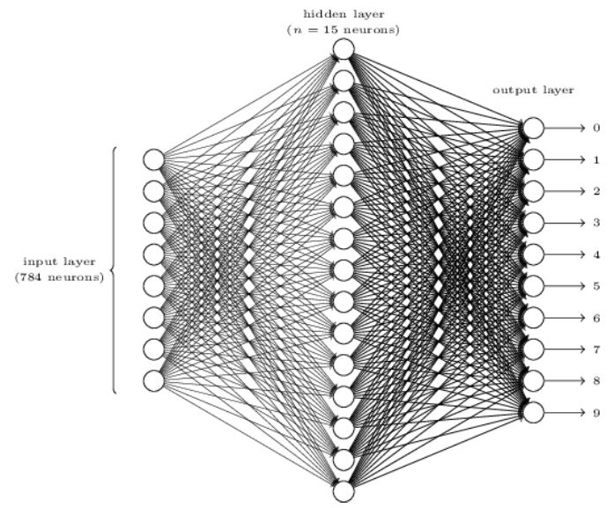

This simple NN illustrates a feed forward network with one hidden and one output layer. Models can be much more complicated; however, this is presented here to contrast the architecture with CNN's.

Important Concepts for CNN
This is a summary from ref(5). This highlights the three concepts implemented by a CNN.
Ref 5) https://www.mathworks.com

Local Receptive Fields
In a typical Neural Network each neuron from the input layer is connected to each neuron in the adjacent hidden layer - see fig(4) - shown here for clarity.

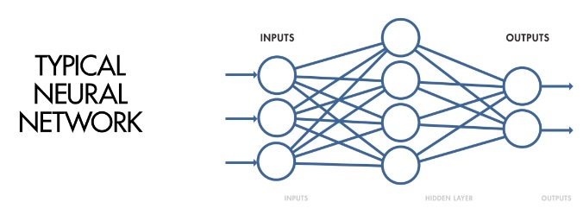
fig(4)

For CNN's there is a designated set of neurons connected to neurons in the hidden layer. These Regions are the Local Receptive Fields (shaded neurons): Convolution is the process that translates these Regions (Local Receptive Fields) across the Image to create a Feature Map from the input layer to hidden layer neurons. see fig(4).

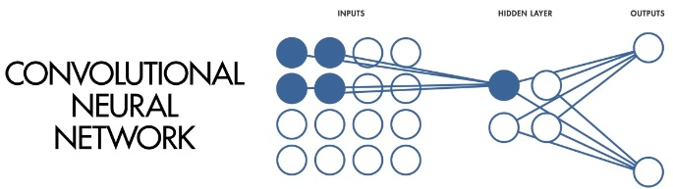
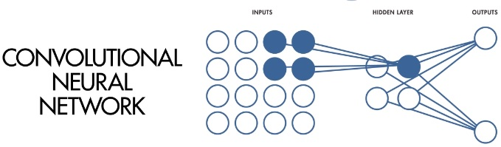
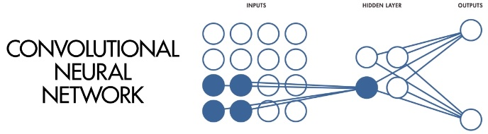
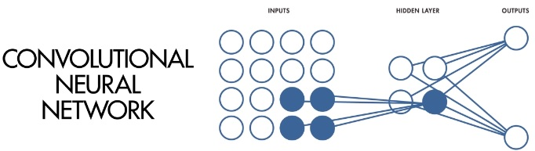
fig(4)
Local Receptive Fields (blue dots) translated through (4,4) array

Shared Weights and Biases
Referring to illustration in fig(3), the values for each weight and bias (i.e. w and b) is determined by the neuron these are connected to. These are then re-calculated and adjusted with each forward and backward pass.

In a CNN the weights and biases are held constant for all given neurons in a given layer.
This means that all hidden neurons are filtering for the same feature in different parts of the same image for a given layer. e.g. all edges, or curves, etc. This can be used to isolate unique characteristics in a given image.

Activation and Pooling
The Activation results in a transformation to each neuron by applying activation functions. Activation functions can be examined at

Ref: https://en.wikipedia.org/wiki/Activation_function

In most cases for Neural Networks, the Sigmoid and ReLU are used.

Rectified Linear Unit or ReLU is an example of an Activation Function. The ReLU takes the output of a neuron and maps it to the highest positive value, if the output is negative, ReLU will map these to value zero(0).

Pooling is used to further reduce the dimensionality of the featured map; pooling condenses small regions of the feature map into a single 'reduced' output. Max Pooling will propagate the maximum value of the region, see fig(5).

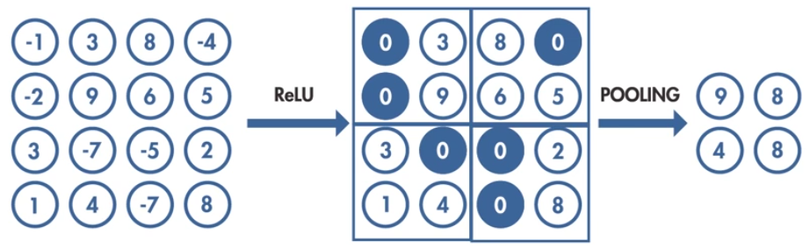
fig(5)

The number of hidden layers can range form 10's to thousands; Pooling reduces the number of parameters downstream and therefore increases computing efficiency for subsequent layers; compare to simple NN shown above - see fig(6).
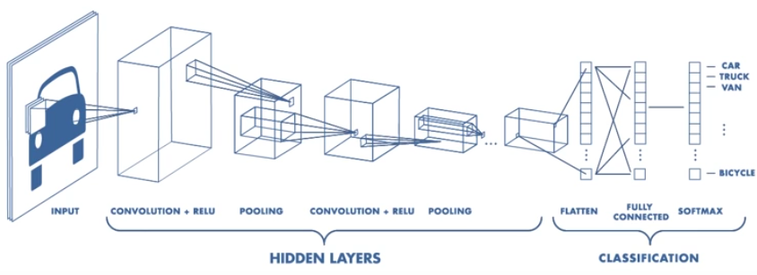
fig(6)

Technical Note:
Keras is a high level API built on TensorFlow (and can be used on top of Theano too). It is more user-friendly and easy to use as compared to TF.

